**Abstract Walnut Wall Mirror With Shelf**

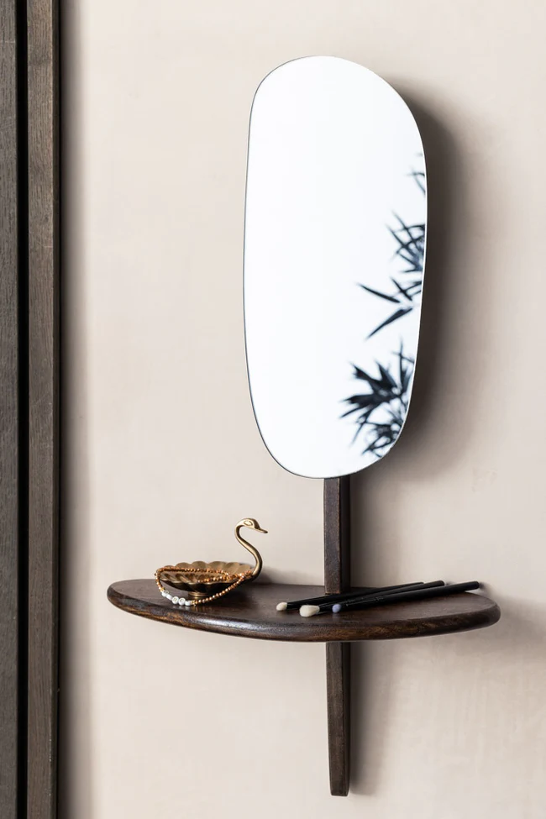The **Abstract Walnut Wall Mirror With Shelf** is a stunning and unique piece that adds a touch of elegance to any room. Featuring a beautifully crafted walnut frame with an abstract design, this mirror serves as both a functional reflective surface and an eye-catching art piece. The integrated shelf offers additional storage, making it perfect for displaying small decor items, plants, or everyday essentials. Its modern yet warm aesthetic makes it ideal for living rooms, entryways, or bedrooms, adding a sophisticated and stylish element to your home while maintaining both form and function.